**Chapter 5 - Nervous System**

**All Lectures Uploaded on YouTube:**

[**https://tinyurl.com/fkm10-biology**](https://tinyurl.com/fkm10-biology)

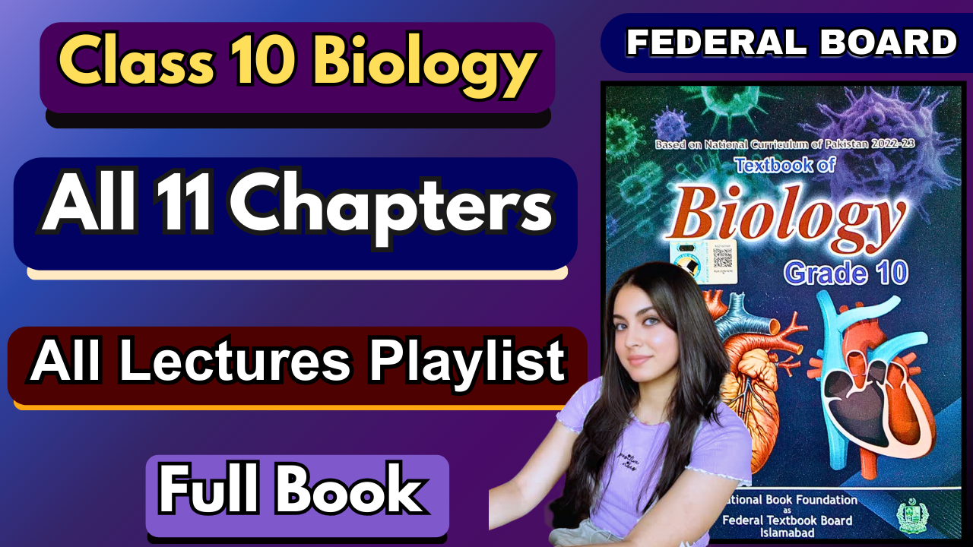

### The body of a human is very complex. To ensure that different parts work together effectively there is a need for communication. The nervous system is made up of specialized cells that allow the body to communicate.

### **5.1. Nervous System and Its Role**

* The nervous system helps organisms receive and respond to environmental information using sense organs (eyes, ears, nose, skin, tongue - sensory receptors).
* These organs detect stimuli like light, sound, smell, touch, and taste, and send messages to the brain, which interprets them.
* The human body performs coordinated functions through this system, ensuring that different organs work together.

### **5.1.1. Role of the Nervous System**

* **Stimulus**: Any change in the environment that causes a reaction in the body.
* **Response**: The reaction to a stimulus.
* **Receptor**: Detects the stimulus.
* **Effector**: Carries out the response (e.g., muscles, glands).

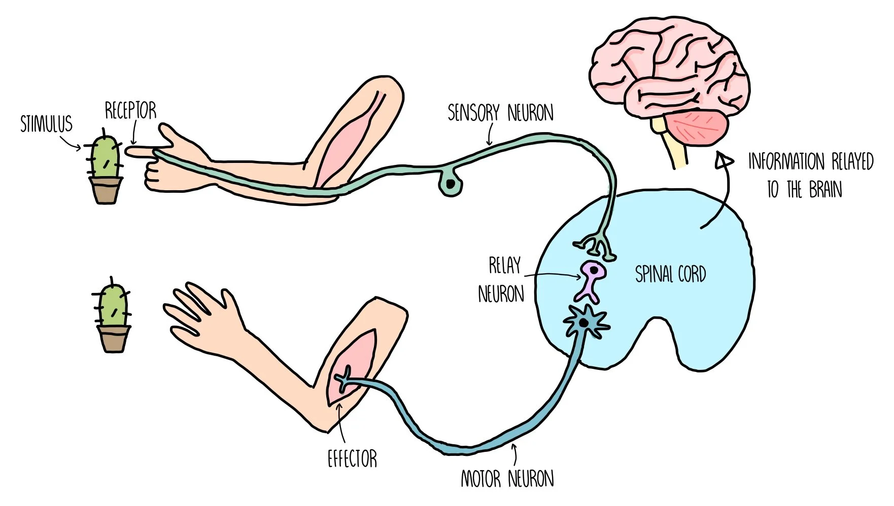

**Functions:**

1. **Sensory Input**: Detection of stimuli (like light or sound) by sensory receptors.
2. **Integration**: Processing and interpreting the signals in the brain/spinal cord (CNS - Central Nervous System).
3. **Motor Output**: Sending signals from CNS to effectors (muscles/glands) to produce a response.

**Pathway of Nervous Response:** Stimulus → Receptor → Central Nervous System (Integration) → Effectors → Response

### **5.2. Human Nervous System**

**Divisions of the Human Nervous System:**

1. **Central Nervous System (CNS)**: Includes the brain and spinal cord.
2. **Peripheral Nervous System (PNS)**: Includes all the nerves coming from the brain and spinal cord.

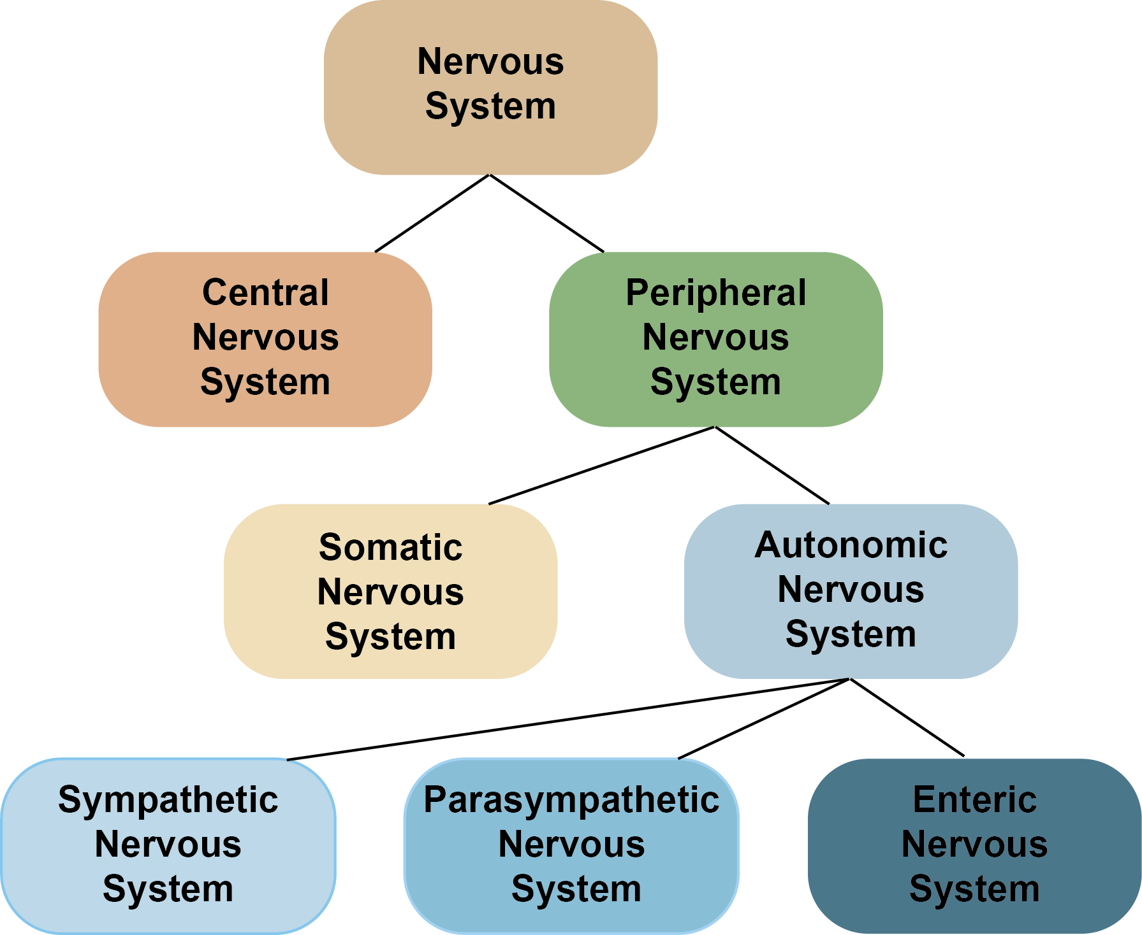

#### **Peripheral Nervous System Subdivisions:**

* **Autonomic Nervous System (ANS)**: Controls **involuntary** actions of internal organs and glands.
  + **Sympathetic System**: Arouses the body (e.g., increases heartbeat).
  + **Parasympathetic System**: Calms the body (e.g., slows heartbeat).
* **Somatic Nervous System**: Controls **voluntary** movements (skeletal muscles).
  + Sensory input (from skin, muscles)
  + Motor output (to muscles)
* The **neuron** is the basic unit of the nervous system.

### **5.2.1. Components of the Central Nervous System**

#### **Brain:**

* Located inside the **cranium** (skull).
* Protected by **meninges** (three protective membranes).
* **Cerebrospinal fluid (CSF)** cushions and nourishes the brain.
* The brain has fluid-filled spaces called **ventricles** connected to the spinal cord’s central canal.

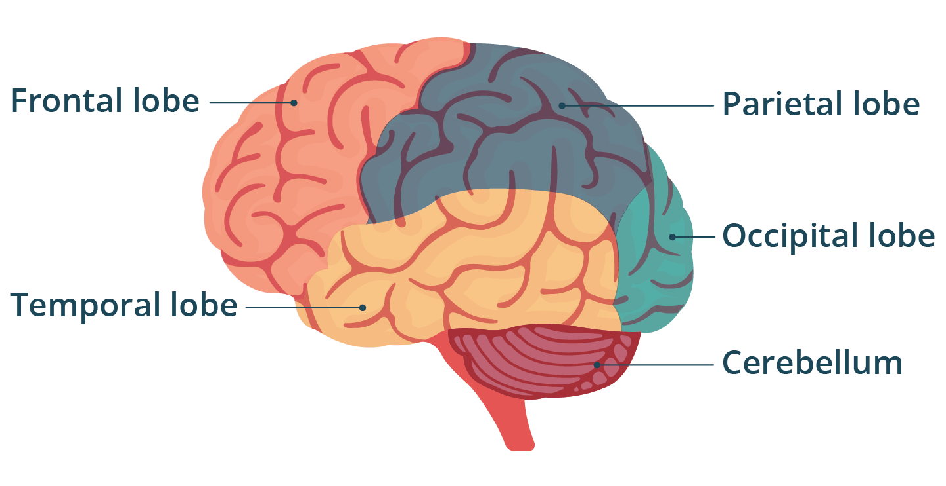**Three Main Parts of the Brain:**

1. **Forebrain**
2. **Midbrain**
3. **Hindbrain**

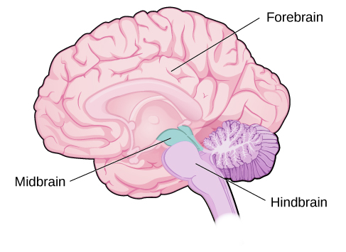

1. **Forebrain**

**Forebrain Structures:**

* **Cerebrum** (largest part)
* **Thalamus**
* **Hypothalamus**

#### **Cerebrum:**

* Center for sensations (hearing, smell, sight), voluntary movement, memory, intelligence, and reasoning.
* Divided into two **cerebral hemispheres**, each with **four lobes**:
  1. **Frontal Lobe**: Voluntary action, speech.
  2. **Parietal Lobe**: Sensation, spatial awareness.
  3. **Temporal Lobe**: Hearing, smelling.
  4. **Occipital Lobe**: Vision.
* **The right hemisphere** controls the left side of the body and vice versa. They are connected by the **corpus callosum** (a bundle of nerve fibres).

**Thalamus**: Located below the cerebrum; receives impulses from sensory areas and passes them to the cerebrum; involved in pain reception and consciousness.

**Hypothalamus**: Below the thalamus; regulates body temperature, appetite, water balance, blood pressure, mood, and links the nervous system to the endocrine system; controls the **pituitary gland** (a pea-sized endocrine gland below it).

#### **Midbrain**

* A tract below the cerebrum receives sensory information and sends it to the forebrain.
* Controls some **auditory reflexes** and **posture**.

#### **Hindbrain**

* **Cerebellum**: The second largest part of the brain; controls balance and muscle coordination.
* **Medulla Oblongata**: Last part of the brain above the spinal cord; controls involuntary processes like heartbeat, blood pressure, and respiration; also regulates reflexes (coughing, sneezing, vomiting).
* **Pons**: Small lobe above the medulla; assists in breathing control; connects cerebellum and spinal cord.

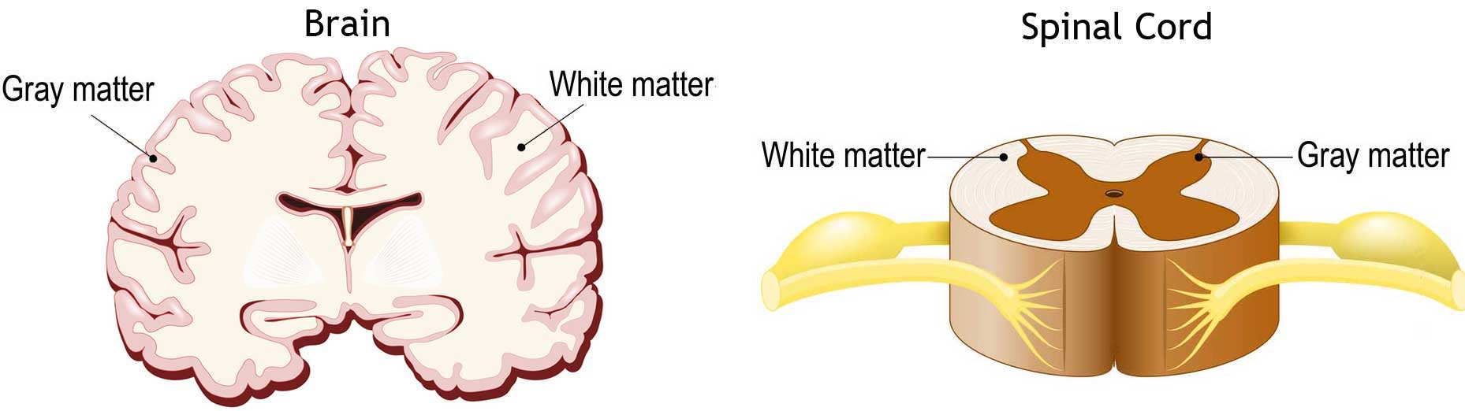

### **Spinal Cord**

* An oval-shaped hollow cylinder of nervous tissue running from the brain’s base; protected by vertebrae.
* 31 pairs of spinal nerves emerge from it; each has **dorsal root** (sensory) and **ventral root** (motor) neurons.
* Acts as a link between brain and body parts; coordinates reflex actions.
* **White Matter**: Myelinated fibres; surrounds grey matter in the spinal cord.
* **Grey Matter**: Cell bodies and non-myelinated fibres; in the brain, grey matter is outside and white matter is inside; in the spinal cord, grey matter is central.

## **5.2.2. Peripheral Nervous System (PNS)**

Links the CNS to the rest of the body.

### **Types of Nerves**

* **Cranial Nerves**: Arise from the brain; 12 pairs.
* **Spinal Nerves**: Arise from the spinal cord; 31 pairs.
* All spinal nerves are mixed; cranial nerves may be sensory, motor, or mixed.

### **Divisions of the PNS**

1. **Somatic Nervous System**
   * Composed of cranial and spinal nerve fibres.
   * Connects CNS to skin and skeletal muscles.
   * Controls voluntary actions.

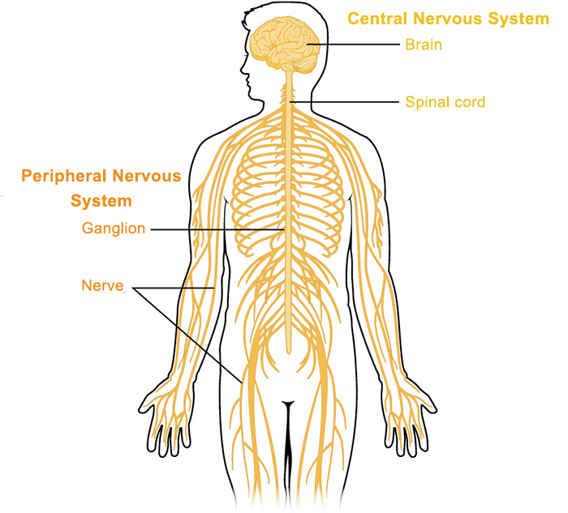

1. **Autonomic Nervous System**
   * Connects CNS to visceral organs (heart, stomach, intestines, glands).
   * Controls involuntary actions.
   * Two subdivisions:
     + **Sympathetic Nervous System**: Active in emergencies; prepares body for "fight or flight."
     + **Parasympathetic Nervous System**: Active in rest; restores normal body functions after sympathetic activation.

### **5.3. Neuron**

* Structural and functional unit of the nervous system.
* **Structure:**
  + **Cell body (Soma):** Contains nucleus and cytoplasm, main metabolic center of the neuron.
  + **Dendrites:** Highly branched extensions; carry impulses toward the cell body.
  + **Axon:** Long fibre transmitting impulses away from the cell body.

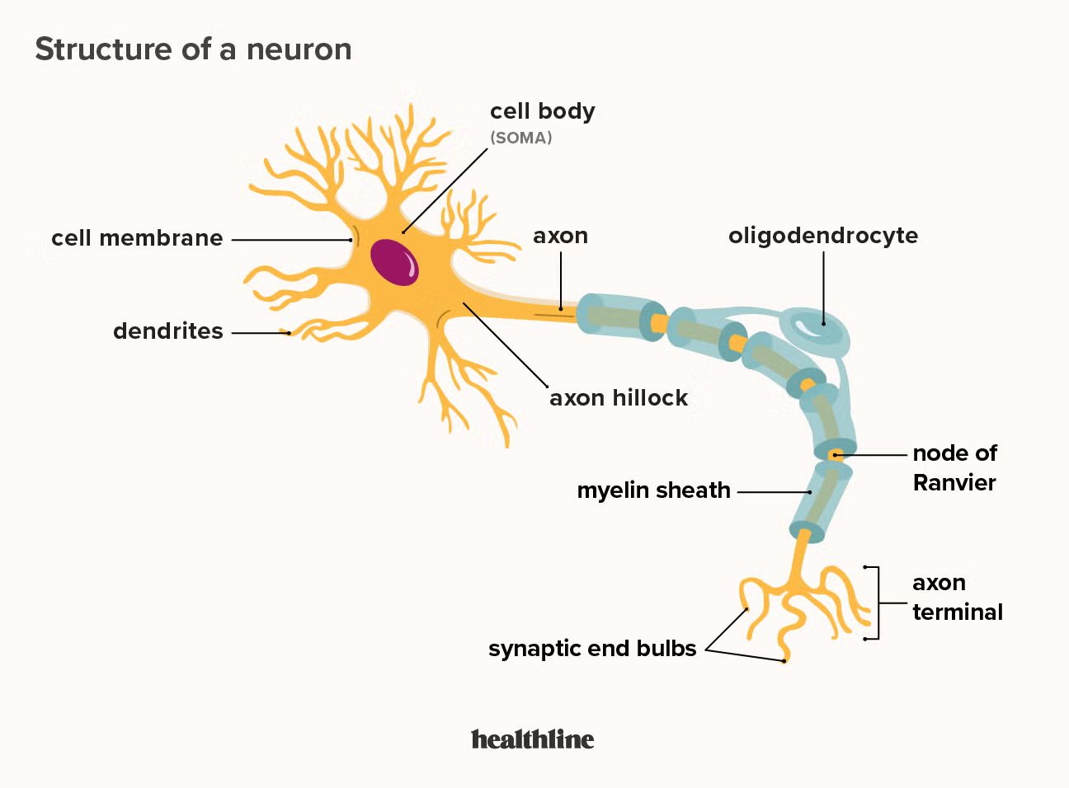

#### **Myelin Sheath**

* **Covering:** Fatty layer covering long neuron fibres; made of Schwann cells.
* **Nodes of Ranvier:** Small gaps between Schwann cells.
* **Function:**
  + Myelin sheath and nodes of Ranvier increase speed of impulse conduction.
  + Acts as an insulator; impulse “jumps” between nodes (saltatory conduction).

### **5.3.1. Types of Neurons**

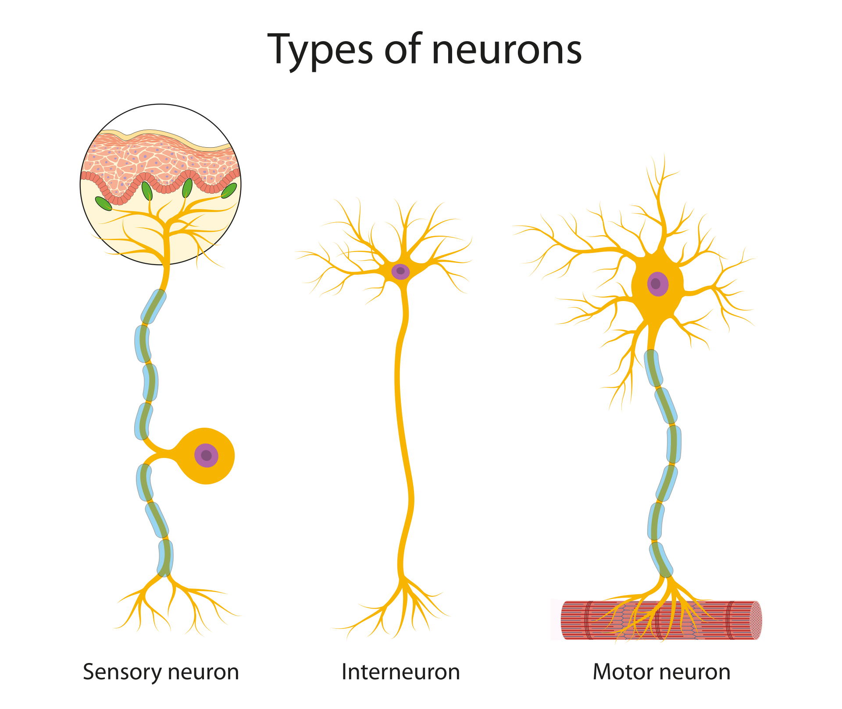

1. **Sensory Neurons:**
   * Carry impulses from receptor to brain/spinal cord.
   * Structure: 1 dendrite + 1 axon.
2. **Motor Neurons:**
   * Carry impulses from brain/spinal cord to effectors (muscles/glands).
   * Structure: 1 dendrite + 1 axon.
3. **Interneurons (Relay Neurons):**
   * Found in brain/spinal cord.
   * Many dendrites and axons.
   * Carry impulses between sensory and motor neurons.

### **5.4. Stimulus**

* Any change in the environment that causes an organism to respond.
* **Types:**
  1. **External Stimuli:** Activated by external changes (e.g., pain, touch, vision, smell, taste, sound, balance).
  2. **Internal Stimuli:** Originates inside the body (e.g., hunger, low energy, blood glucose level, blood pressure, homeostasis).

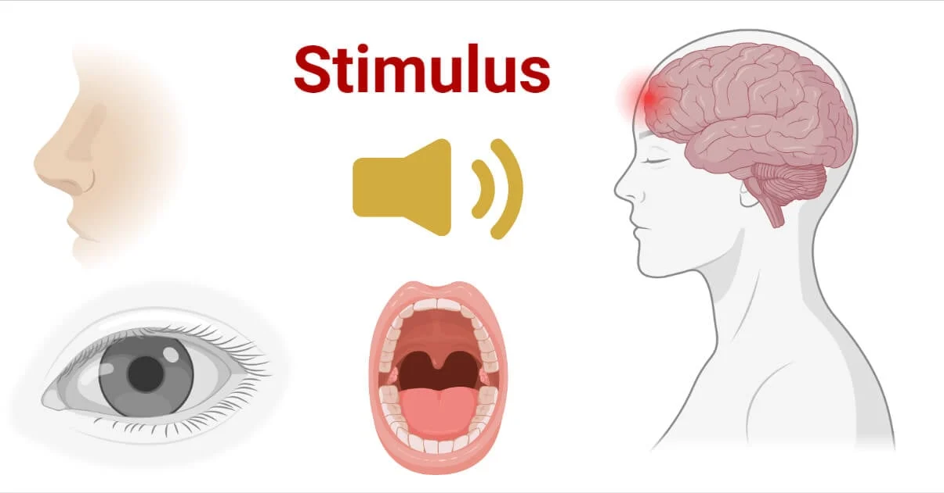

### **5.5. Nerve Impulses**

* **Nature:** Electrical in nature; caused by a difference in electrical charge across the neuron membrane.

**Resting Potential:**

* + When a neuron is not transmitting impulses, it is in a resting state.
  + Sodium-potassium pump actively moves Na⁺ out and K⁺ in, using ATP.
  + Outside of the neuron becomes positively charged compared to inside (negative).
  + This difference in electrical charge is called the **resting potential**.

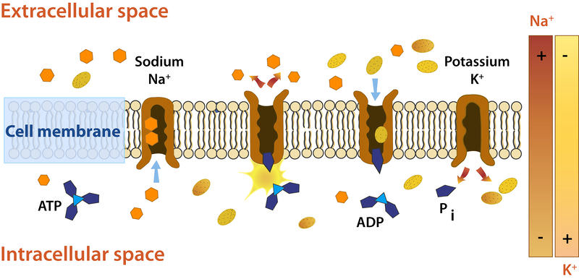

**Action Potential:** A nerve impulse is a sudden reversal of the electrical charge across the membrane of a resting neuron, known as an **action potential.**

* + Begins when a neuron receives a chemical signal from another cell.
  + This signal opens **sodium ion channels**, allowing **positive sodium ions** to flow back into the cell.
  + The **inside of the cell becomes positively charged** compared to the outside.
  + This reversal of charge moves rapidly down the axon like an electric current.
  + An action potential travels along an axon in milliseconds.
  + Ions cross the membrane **only at the nodes** between myelinated sections.
  + Action potential **jumps** from node to node (**saltatory conduction**), increasing speed.

### 

### 

### **5.6. Synapse**

* Junction between two neurons (or a neuron and another excitable cell).
* **Structure:**
  + Small gap called **synaptic cleft** between neurons.
  + **Presynaptic neuron:** Sends impulse.
  + **Postsynaptic neuron:** Receives impulse.

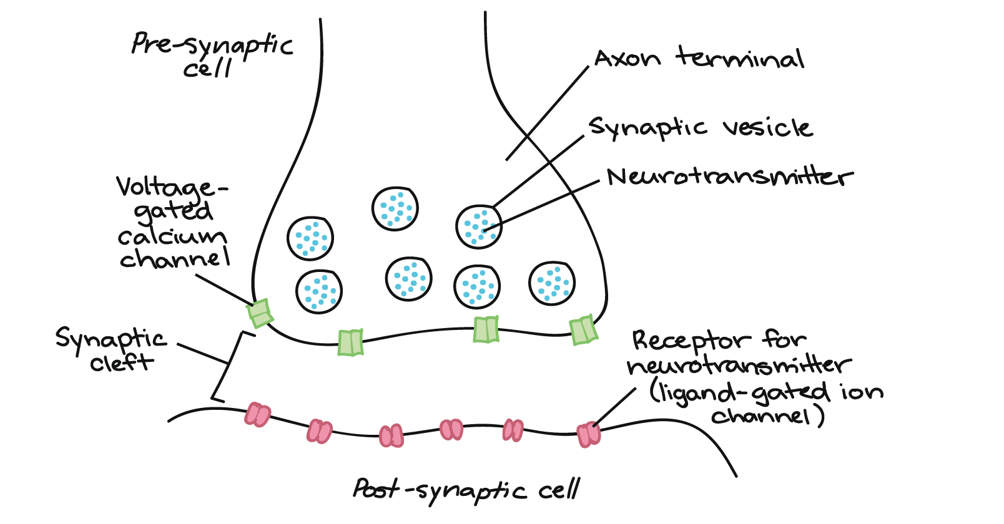

* **Function:**
  + Impulse cannot cross synaptic cleft directly; it uses chemical transmission.
  + Neurotransmitters are released from the axon terminal → cross synaptic gap → bind to receptors on postsynaptic neurons → trigger new impulse.
* **Direction:** Impulses pass in one direction only.

## **5.7. Neurotransmitters**

* Chemical messengers carrying signals from one neuron to the next target cell.
* **Location**: Stored in **axon terminals** inside thin-walled sacs called **synaptic vesicles**.
* **Mechanism**:
  1. Nerve impulse reaches the axon terminal → triggers vesicles to fuse with cell membrane.
  2. Neurotransmitters are released into the **synaptic cleft**.
  3. They bind to **specific receptors** on the target cell.
  4. Binding triggers a change in the target cell (e.g., electrical signal in another nerve cell, muscle contraction, or hormone release).

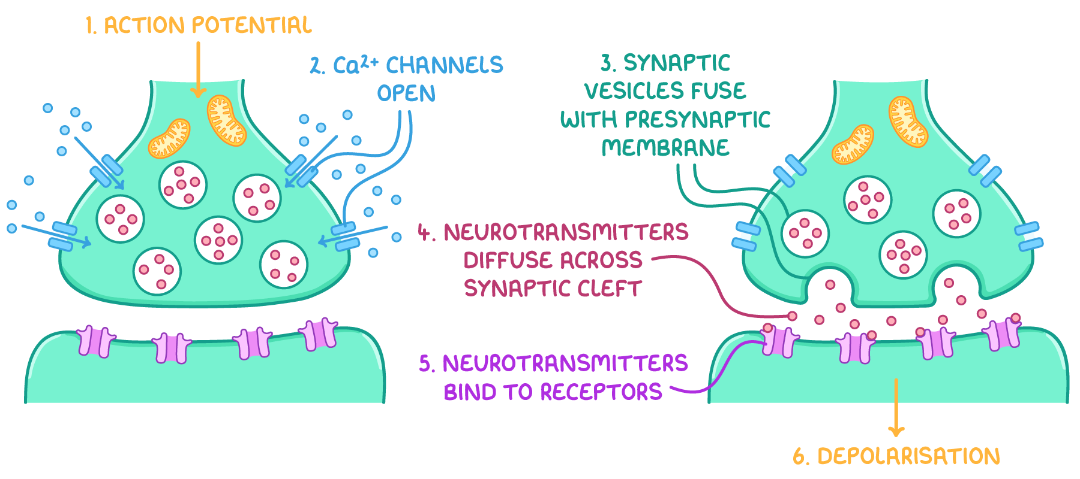

* **Examples**: Epinephrine, norepinephrine, glycine, serotonin.
* **Fate of Neurotransmitters**:
  1. **Diffusion** – fade away.
  2. **Reuptake** – reabsorbed by the releasing neuron.
  3. **Degradation** – broken down by enzymes in the synapse.

## **5.8. Reflex Action**

* Automatic, immediate responses to stimuli without conscious control.
* **Types of Actions**:
  + **Voluntary**: Controlled by will, not always immediate.  
     *Examples*: Running, walking.
  + **Involuntary**: Automatic, without awareness.  
     *Examples*: Heartbeat, peristalsis, secretion of gastric juices, reflexes.
* **Reflexes**:
  + Responses to internal or external environmental changes.
  + Certain reflexes bypass the brain; the **spinal cord** acts as the control centre.
  + Such reflexes are **fast** and **involuntary**.

### **Sequence of Events in a Hot Object Reflex**

1. Heat stimulates **nerve endings (receptors)** in the skin.
2. **Impulses** travel via the sensory neuron to the spinal cord.
3. In the spinal cord:
   * Impulses pass across a synapse to the interneuron.
   * Then across another synapse to the motor neuron.
4. Impulses leave the spinal cord through the motor neuron to the effector.
5. The effector (arm muscle) contracts, causing the hand to withdraw.

* **Other Examples:** Sneezing, coughing, blushing, scratching, blinking when something approaches the eye.

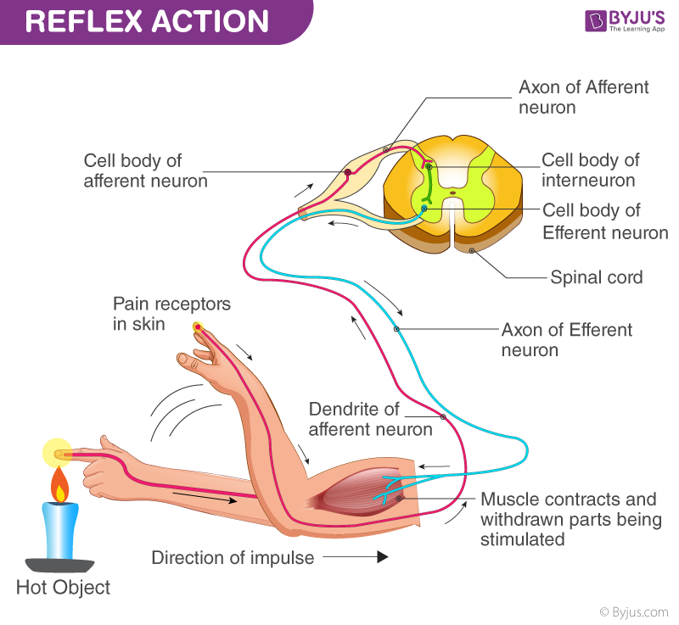

## **Reflex Arc**

* Pathway for impulses from receptor to effector in a reflex.
* **Components:**
  1. Sense organ (receptor)
  2. Sensory neuron
  3. Interneuron (in reflex centre: spinal cord/brain)
  4. Motor neuron
  5. Effector (muscle/gland)

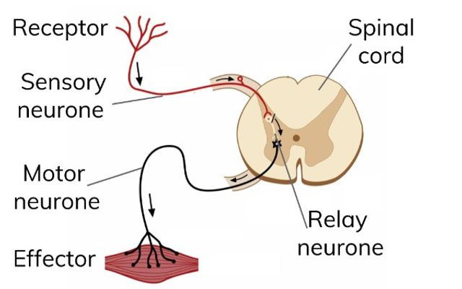

## **5.9. Endocrine System**

* **Hormones:** Chemicals from ductless glands, carried in blood to a **target organ**.
* **Functions:**
  + Alter activity of target organs.
  + Regulate and control many body functions.
* **Speed:** Slower acting than nervous system but has longer-lasting effects.
* **Importance:** Allows coordination of both immediate and long-term responses.
* **Endocrine vs Exocrine:** Endocrine glands secrete directly into blood; exocrine glands use ducts.

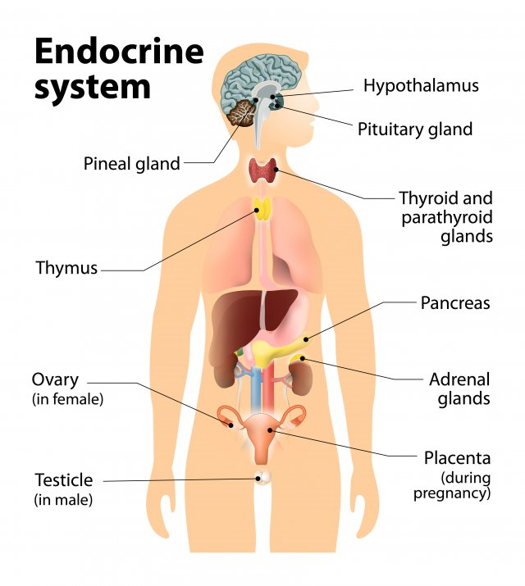**Major Endocrine Glands:**

1. Pituitary gland
2. Thyroid gland
3. Parathyroid glands
4. Pancreas
5. Adrenal glands
6. Gonads (Testes in males, Ovaries in females)

## **5.9.1. Pituitary Glands**

* Attached to hypothalamus; pea-sized; consists of two lobes (anterior and posterior).
* Called "master gland" as it controls other endocrine glands.

### **Anterior Lobe**

* Regulates and maintains development/functions of endocrine glands.
* **Hormones Secreted**:
  + **Thyroid Stimulating Hormones (TSH)** → Controls thyroid gland.
  + **Growth Hormone (Somatotrophic Hormone)** → Affects growth of the body.
    - Deficiency in childhood → **Pituitary dwarfism** (short stature).
    - Excess in childhood → **Gigantism** (abnormally large body).
    - Excess in adults → **Acromegaly** (overgrowth of hands, feet, face).
* Also controls adrenal glands and gonads.

### **Posterior Lobe**

* Secretes:
  + **Oxytocin** → Causes uterine contractions during childbirth, milk ejection.
  + **Antidiuretic Hormone (ADH)** → Reabsorbs water in kidneys.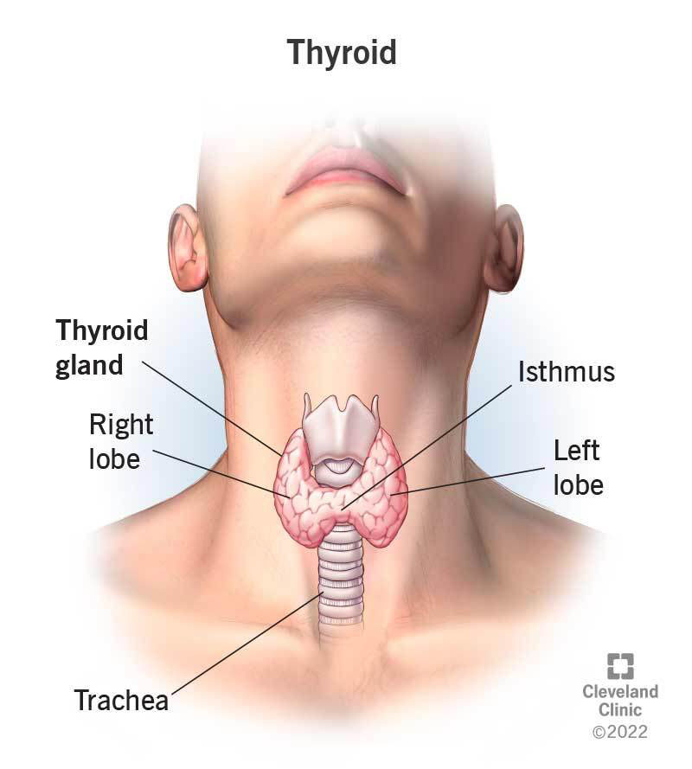
    - Deficiency → Excess urine output → **Diabetes insipidus**.

## **5.9.2. Thyroid Gland**

* Present in the neck, near the trachea just below the larynx.
* **Structure**: Two lobes.
* **Hormone**: **Thyroxine**
  + Regulates metabolism.
  + Controls growth, maturation of tissues, skeletal development.
  + Deficiency in children→ **Cretinism** (stunted growth, mental retardation).
  + Deficiency in adults → Enlargement of thyroid (Goitre).
  + Requires iodine for synthesis.
* **Calcitonin** → Lowers blood calcium by depositing calcium in bones.

## **5.9.3. Parathyroid Glands**

* **Location**: Four tiny glands located on the thyroid gland.
* **Hormone**: **Parathormone**
  + Opposite function of calcitonin.
  + Increases blood calcium by releasing calcium and phosphate from bones.

## **5.9.4. Pancreas**

* **Type**: Both endocrine & exocrine gland.
* **Endocrine Part**: Islets of Langerhans.
  + **Alpha cells** → Secrete **Glucagon**.
  + **Beta cells** → Secrete **Insulin**.

### **Functions:**

* **Insulin** → Lowers blood glucose after meals by:
  + Helping glucose enter cells.
  + Converting glucose to glycogen.
* **Glucagon** → Opposite to insulin.
  + Raises blood glucose by converting glycogen to glucose in liver.
* **Disorder**: **Diabetes Mellitus**
  + Caused by deficiency of insulin (beta cells not producing enough).
  + Symptoms: High blood sugar, glucose in urine.
  + Treatment: Regular insulin injections or medicines.

## **5.9.5. Adrenal Glands**

* **Location**: On top of kidneys. Each gland has:
  + **Adrenal Cortex** → Produces **Corticosteroids** (control metabolism, immune response, etc.).
  + **Adrenal Medulla** → Produces **Adrenaline (epinephrine)** & **Noradrenaline (norepinephrine)**.

### **Functions:**

* **Adrenaline** ("emergency hormone"):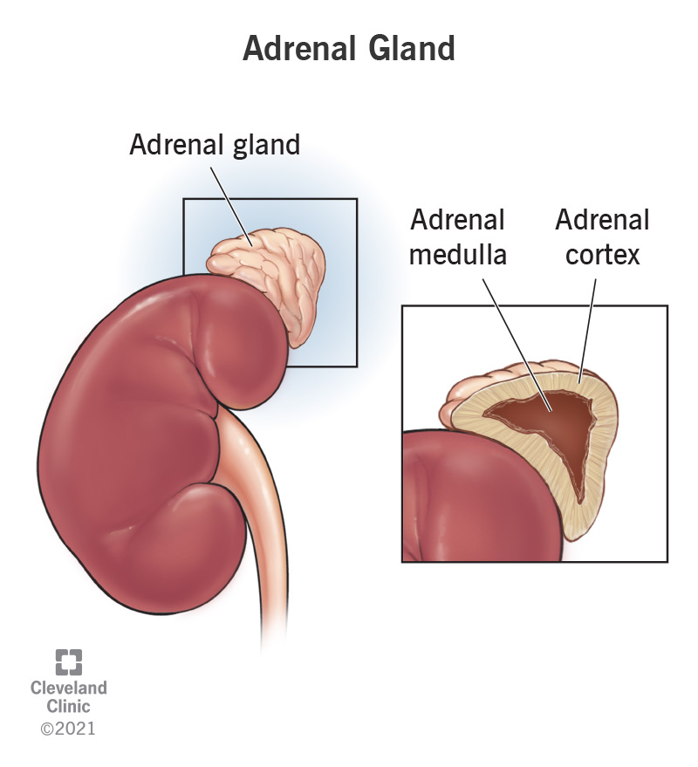
  + Prepares the body for **fight or flight**.
  + Increases heartbeat, blood pressure, respiration.
  + Diverts blood to muscles.
* **Noradrenaline**:
  + Maintains blood pressure.
  + Constricts blood vessels.

## **Gonads**

* **Testes (Males)**
  + Hormone: **Testosterone**
  + Function: Development of secondary sexual characteristics (facial hair, deep voice, body hair, etc.).
* **Ovaries (Females)**
  + Hormone: **Oestrogen (Estrogen)**
  + Function: Development of secondary sexual characteristics (breast development, menstrual cycle regulation).



